25.84: a) 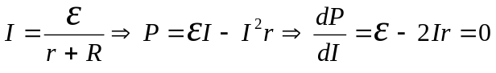 for maximum power output.
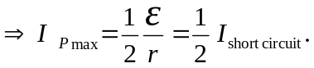
b) For the maximum power output of (a), 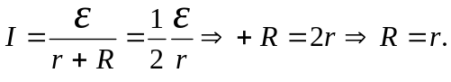
Then, 